**Approved by …………………………. Ch.Zolzaya /Head of English Language Department/**

**Oral Quiz for S. CE102**

**FORM 1**

**PART I:**

**Comprehension topic questions: Answer each question correctly. (5 points)**

1. What does a help desk technician do?

- Help desk technician provides technical support and assistance to customers on phone

2. What is the most important gadget to you? Why?

- I will say that it’s my phone because it’s light weight and almost combined all technology that I need. Those techs are taking photos, video, recording voice, taking note, calling to someone, traveling through the internet, Instagram, Facebook, TikTok etc.

3. Who was the light bulb invented by?

- Thomas Edison invented the light bulb in 1879.

4. What types of numbers can you name?

- I am not math guy but I know that

5. What do fractions refer to? How do we say them in English?

- Fractions are like pieces of a pizza or a cake. If you cut a pizza into 8 equal pieces and you take 2 of them, then you have 2 out of 8 pieces, in the other word that are 2/8 of the pizza**PART II:**

**A: Vocabulary: Which part of speech is each word? Give a definition or use them in an example sentence. (5 points)**

For example: **artificial**

Part of speech adjective

Definition: not natural, made by people

Sentence: A modern artificial hip joint is designed to last 15 years.

1. Construction- noun, the work of building or making something, This website is currently under construction

2. Bargain- verb , to agreement between parties fixing obligations of each

3. Goggles- noun, special glasses to protect the eyes from water etc, some swimmers wear special glasses

4. Fall- verb to suddenly go down on to the ground or towards the ground by accident, he fell badly and broke his leg

5. Roll up- phrasal verb , to arrive at a particular place or event usually lates, they rolled up at the party two hour late

**B: Look at the picture and describe what you can see, making more than ten sentences. (5 points)**

Use language below:

-How many people can you see in the picture?

-I see 7 to 9 people in this picture. I can’t see some of them clearly.

-What do these people do?

- I think these people are civil engineers or underground engineers.

-Where are they?

-From what I see, I think they’re in an underground tunnel.

-What are they doing?

-in my opinion, they are fixing the underground pipe.

-What clothes are they wearing?

-They are wearing safety helmets, construction vests, masks, work pants and protective boots for their safety.

-What are they feeling?

-I think they’re feeling cold because there is little to no sunlight in the underground. Also because it’s moist and damp

-What items/tools/… are there?

-pumping machine(?), headlamps etc.

-Name the shapes you can see in the picture.

-I can see cylind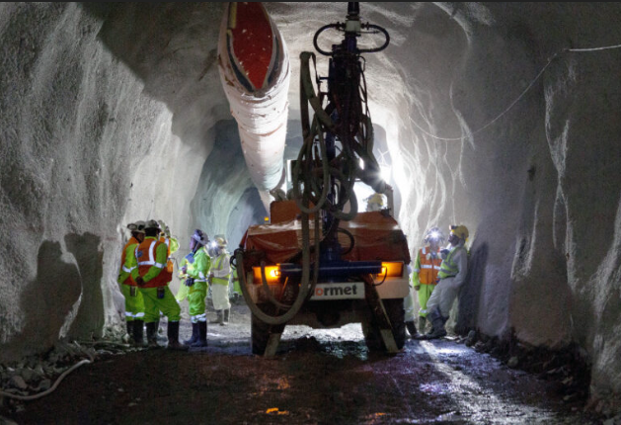er, a semi-circle, rectangle, oval shapes.



**FORM 2**

**PART 1:**

**Comprehension topic questions: answer each question correctly. (5 points)**

1. What does a warehouse manager do?

-A warehouse manager works for a paper company, receives shipments and checks quantities, keeps records of inventory and manages a database.

1. What’s special about the Carver?

-it’s a two-seater car that thinks it’s a motorbike.

1. What’s the subject of the Car Chat Show?

-  The subject of the Car Chat Show is the most exciting ways to get around town

1. Why does Peter think the Segway HT is ‘the coolest thing’?

-There are sophisticated sensors in the platform, and there is no accelerator no

      brakes, and it’s less noisy than a car.

1. What happens to the Carver when it goes around a bend?

-its back tilts over 45 degrees.

**PART II: (10 points)**

**A. Vocabulary: Which part of speech is each word? Give a definition or use them in an example sentence.**

**(5 points)**

For example: **artificial**

Part of speech adjective

Definition: not natural, made by people

Sentence: A modern artificial hip joint is designed to last 15 years.

1. Project- noun, a study of particular subject done over a period of time , he’s doing a class project on pollition

2. Visit- verb, to go to a place in order to look at it, we visited a few galleries while we were in prague

3. Shelf – noun, a flat board fixed horizontally against a wall so objects can be stored on it

4. Decrease- verb , to become less or make something become less , total unemployment decreased this year

5. Hazard- noun , something that is dangerous and likely to cause damage , the busy traffic entrance was a hazard to pedestrains

**B: Look at the picture and describe what you can see, making more than ten sentences. (5 points)**

--How many people can you see in the picture?

- I can see 6 people in this picture. 4 of them are on the left side and 2 of them are on the right.

-What do these people do?

- these people are civil engineers who work in an underground construction site.

-Where are they?

-They are in an underground construction site

-What are they doing?

- in my opinion, they are fixing the underground pipes.

-What clothes are they wearing?

- They are wearing safety helmets, construction vests, masks, work pants and protective boots for their safety.

-What are they feeling?

- I think they’re feeling hot because there is probably an air conditioning system in the underground using electrical generator.

-What items/tools/… are there?

- There are safety and warning signs, water hoses, trucks etc.

-Name the shapes you can see in the picture? - I can see squares, triangles, circles, cylinders and rectangles etc.

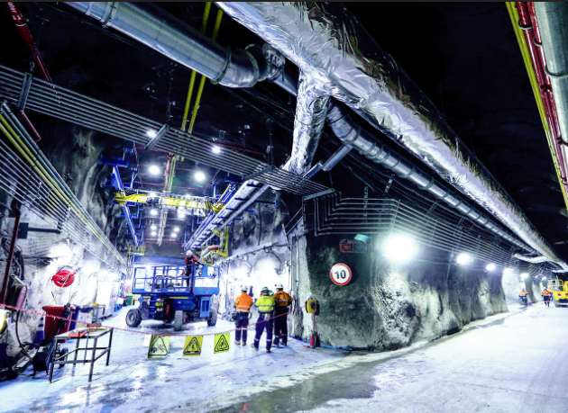

**FORM 3**

**PART 1:**

**Comprehension topic questions: answer each question correctly. (5 points)**

1. What does a quality controller do?

- Quality controller checks products to make sure they're perfect before you get to use them.

2. What special features do James Bond’s watches have?

- James Bond's watch can cut holes in the wall and turn on a very bright blue light.

3. What do safety precautions mean and why are they important?

- Safety precautions are like moves and actions to keep you safe.For example, wearing a helmet when riding a bike, looking both ways before crossing the street.

4. Explain how to change the oil and oil filter in the car.

-Get the car ready: Park the car on a flat surface and turn off the engine. Open the hood of the car and locate the oil filter and drain plug.

Drain the old oil: Place a container underneath the drain plug and remove it with a wrench. Let the old oil drain out completely.

Replace the oil filter: Locate the oil filter and remove it using an oil filter wrench. Replace it with a new oil filter, making sure it's tightened securely.

Add new oil: Replace the drain plug and use a funnel to pour in the new oil. Check the car's manual for the correct type and amount of oil to use.

Check the oil level: Start the engine and let it run for a minute or two. Turn off the engine and check the oil level with the dipstick. Add more oil if needed, then close the hood.

5. What shapes can you name in English?

- Circle,square,rectangle,triangle, oval,rhombus,pentagon,hexagon,octagon

**PART II: (10 points)**

**A. Vocabulary: Which part of speech is each word? Give a definition or use them in an example sentence. (5 points)**

For example: **artificial**

Part of speech adjective

Definition: not natural, made by people

Sentence: A modern artificial hip joint is designed to last 15 years.

1. Flame- noun, a stream of hot , burning gas from something on fire . The flames grew bigger as the fire spread

2. Spill- verb , to flow , move , fall or spread over the edge or outside the limits of something. I spilled coffee on my shirt

3. Ladder- noun , a piece of equipment used for climbing up and down. She was up a ladder

4. Reduce- verb , to become or to make something become smaller in size . amount etc. My weight reduced when I stop

5. Accident- noun , something bad that happens that is not expected or intended. The sign was damaged in an accident

**B: Look at the picture and describe what you can see, making more than ten sentences. (5 points)**

-How many people can you see in the picture?

I can see 4 people in this picture.

-What do these people do?

They are builders.

-Where are they?

They are the foundation of a building.

-What are they doing?

Two of them are carrying wood and other 2 people are talking about how they should build this construction.

-What clothes are they wearing?

They are wearing safety helmets, colorful jackets, and black suit.

-What are they feeling?

They feel hot. Because it looks like a sunny day and they are working outside.

-What items/tools/… are there?

In this picture i don’t see any tools but builders usually use tools like axes, hammer, screwdriver, ladder, and measuring tape.

-Name the shapes you can see in the picture.

I can see shapes like triangle, square, rectangle, and oval.

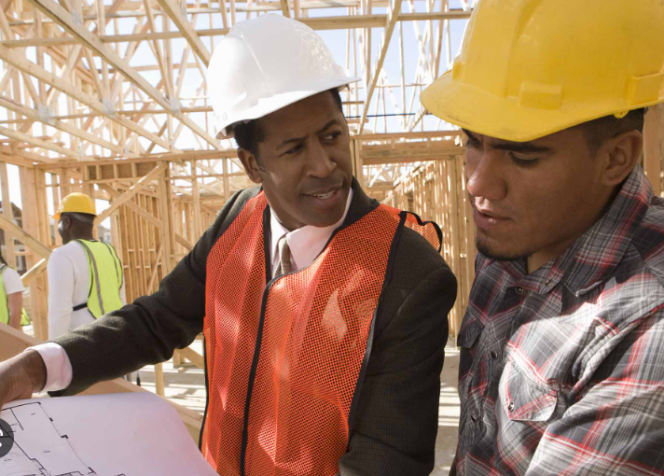

**FORM 4**

**PART 1:**

**Comprehension topic questions: answer each question correctly. (5 points)**

1. What does a mechanical engineer do?

- A mechanical engineer builds machines and devices that can do amazing things, like cars that can drive themselves or robots that can help us with tasks.

2. What do you know about the Great Sphinx?

- The Great Sphinx is a really old statue that's shaped like a creature with the head of a human and the body of a lion. It's located in Egypt, and it's really big.

3. What is GPS? What do people use GPS for?

- GPS stands for "Global Positioning System". It's a technology that helps people figure out where they are and how to get to where they want to go. There are people such as travelers, archaeologists, pilots, and sailors.

4. Explain the rules for the game “Geo-caching”.

Find a geocache: The first step is to find a geocache. A geocache is a small container hidden somewhere outdoors, like in a park or in the woods. You can find a list of geocaches in your area by going to the geocaching website or app.

Use GPS: Once you find a geocache, you'll need to use GPS to help you navigate to its exact location. You can use a phone or a GPS device to do this.

Sign the logbook: When you find the geocache, open it up and sign the logbook inside. This lets other people know that you found it.

Trade items: Some geocaches have small toys or trinkets inside. If you want to, you can take one of these items and replace it with something of your own. Just make sure to follow any specific rules listed on the geocache's page.

Put the geocache back: After you're done, put the geocache back exactly where you found it so that other people can find it too.

5. What information do you need to write in the logbook?

- I should write my geocaching username, the date and time i found the geocache, and any comments i want to add about i experience

**PART II: (10 points)**

**A. Vocabulary: Which part of speech is each word? Give a definition or use them in an example sentence.**

**(5 points)**

For example: **artificial**

Part of speech adjective

Definition: not natural, made by people

Sentence: A modern artificial hip joint is designed to last 15 years.

1. Compare- verb , to examine or look for the difference between two or more things. This road is quite busy compared to ours

2. Sample- noun , a small amount of something that shows you what the rest is should be like . a free sample of shampoo

3. Rectangular- adjective, shaped like a rectangle. The room is very rectangular

4. Rise- verb , to move upwards. At 6 am we watched the sun rise

5. Horizaontal- adjective, parallel to the ground or to the bottom or top edge of something

**B: Look at the picture and describe what you can see, making more than ten sentences. (5 points)**

-How many people can you see in the picture?

I can see two people but maybe many people are inside of the bus.

-What do these people do?

They 2 clean our city. And the bus driver drives the bus.

-Where are they?

They are the cleaners of our city. Like our mom and dad used to clean our home.

-What are they doing?

They are throwing snow to the outside of the road.

-What clothes are they wearing?

They are wearing colorful jackets to prevent them from getting in an accident, and warm clothes because it’s winter.

-What are they feeling?

Maybe they feel tired, cold, and hungry.

-What items/tools/… are there?

There are snow shovels.

-Name the shapes you can see in the picture.

I can see shapes like triangle, square, rectangle, oval and cylinder.

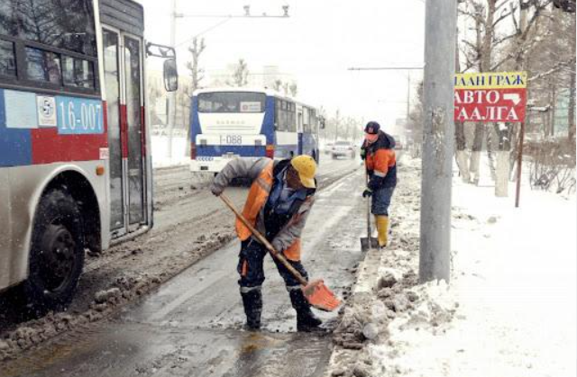

**FORM 5**

**Part 1:**

**Comprehension topic questions: answer each question correctly. (5 points)**

1. What does a civil engineer do?

2. Who was Larry Walters?

3. How did Larry Walters communicate with his friends on earth?

4. How did Larry Walters come back to earth?

5. Classify these things to device category: a washing machine, hammer, a motorized cup that stirs your tea for you, a vacuum cleaner, a compass, a garden spade, a computer.

**Part II: (10 points)**

**A. Vocabulary: Which part of speech is each word? Give a definition or use them in an example sentence. (5 points)**

For example: **artificial**

Part of speech adjective

Definition: not natural, made by people

Sentence: A modern artificial hip joint is designed to last 15 years.

1. Vehicle- noun , a machine used for transporting people on land , Tractors are farm vehicles

2. Mix- verb, to combine , Mix the eggs into the flour

3. Semi-circular- adjective, shaped like half circle , the chairs wore placed in a semicircular arrangement

4. Wage- noun , amount of money that is paid to an employee. The job pays very low wages

5. Handbrake- noun, a device sperated by hand , prevents a vehicle from moving , You’re supposed to put the handbrake on whenever you stop on a hill

**B: Look at the picture and describe what you can see, making more than ten sentences. (5 points)**

-How many people can you see in the picture?

-What do these people do?

-Where are they?

-What are they doing?

-What clothes are they wearing?

-What are they feeling?

-What items/tools/… are there?

-Name the shapes you can see in the picture.

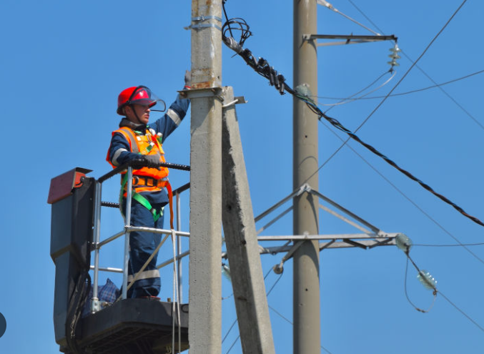

**FORM 6**

**PART I:**

**Comprehension topic questions: answer each question correctly. (5 points)**

1. What does an architect do?

2. What kind of company is Color Graphics?

3. Why did the manager stop the presses?

4. What kind of changes did they make to the production processes?

5. What reduction did the company achieve?

**PART II: (10 points)**

**A. Vocabulary: Which part of speech is each word? Give a definition or use them in example sentence. (5 points)**

For example: **artificial**

Part of speech: adjective

Definition: not natural, made by people

Sentence: A modern artificial hip joint is designed to last for at least 15 years.

1. Pulley- noun , a piece of equipment for moving heavy objects up or down, The stone had to be lifted into position with a pulley

2. Increase – verb, to become larger in amount or size. Gradually incease the tempetarure to boiling point

3. Cylindrical – adjective , shaped like cylinder

4. Inventory – noun , a detailed list of all the things in a place . A set of 24 glided chairs appear on the inventory of the house

5. Recommend- verb , suggest that a particular action should be done . I can recommend the chicken in mushroom sauce

**B. Look at the picture and describe what you can see, making more than ten sentences. (5 points)**

Use the language below:

- How many people can you see in the picture?

- What clothes are they wearing?

- What do these people do?

- What are they feeling?

- Where are they? What items/tools/….. are there? etc.

- What are they doing?

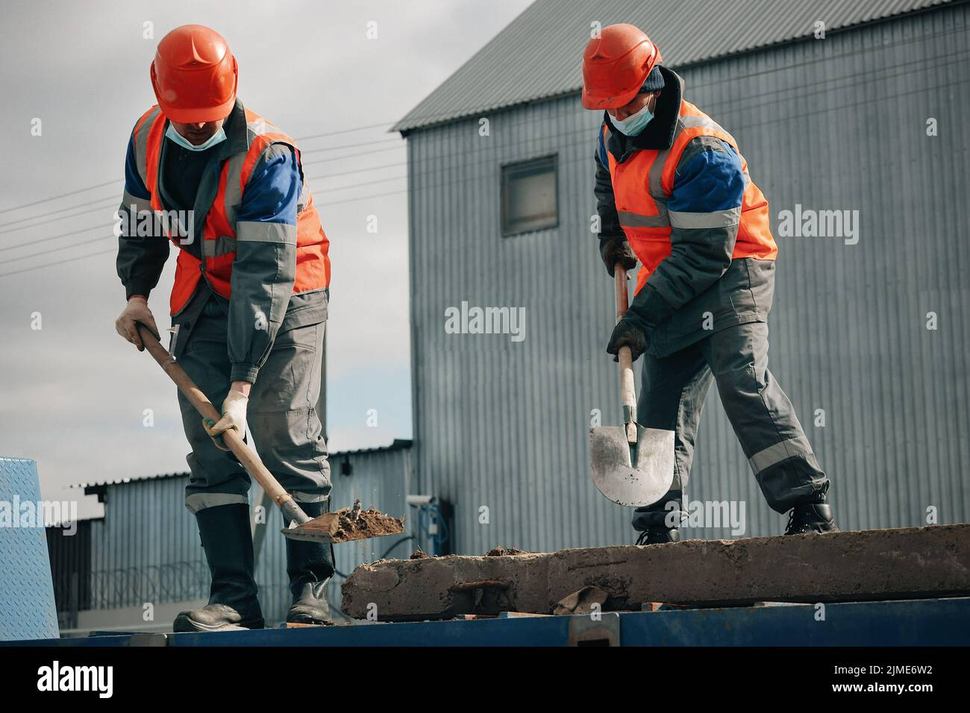

**FORM 7**

**PART I:**

**A. Comprehension topic questions: answer each question correctly. (5 points)**

1. ﻿﻿﻿What does an electrical engineer do?

2. ﻿﻿﻿Why do engineers need to wear special clothing or don't need to wear special clothing?

3. ﻿﻿﻿Where is the Hoover Dam located?

4. ﻿﻿﻿When was the Hoover Dam built and how long did it take to build?

5. ﻿﻿﻿How much concrete did they use to build the Hoover dam?

**PART II: (10 points)**

**A. Vocabulary: Which part of speech is each word? Give a definition or use them in example sentence. (5 points)**

For example: **artificial**

Part of speech: adjective

Definition: not natural, made by people

Sentence: A modern artificial hip joint is designed to last for at least 15years.

1. Pivot – noun , a fixed point supporting something which turns or balances

2. ﻿﻿﻿Rotate – verb, to turn or cause something to turn in a circle , especially around a fixed point . The wheel rotates around an axle

3. ﻿﻿﻿Triangular- adjective , shaped like a triangle . A traindular plot of land

4. ﻿﻿﻿Emission – noun , an amount of gas , heat , light, etc. That’s sent out . Bioluminescence is the emission of light from living organism

5. ﻿﻿﻿Injury- noun , physical harm or damage to someone’s body caused by an accident or an attack a head injury

**B. Look at the picture and describe what you can see, making more than ten sentences. (5 points)**

Use the language below:

- ﻿What is the device for?

- ﻿﻿How does it work?

- ﻿﻿What part does it have?

- ﻿﻿What shape is it?

- ﻿﻿What color is it?

- ﻿What materials are used to make it?

- ﻿﻿Who can use it?

- ﻿﻿Who makes it?

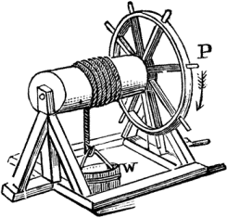

**FORM 8**

**PART I:**

**A. Comprehension topic questions: answer each question correctly. (5 points)**

1. ﻿﻿﻿What does a computer engineer do?

2. ﻿﻿﻿How high is the Great Sphinx?

3. ﻿﻿﻿Is the Great Sphinx hollow or solid?

4. ﻿﻿﻿What ways are there to get from MUST to the Central Post Office?

5. ﻿﻿﻿What special features do James Bond's gadgets have?

**PART II: (10 points)**

**A. Vocabulary: Which part of speech is each word? Give a definition or use them in example sentence. (5 points)**

For example: **artificial**

Part of speech: adjective

Definition: not natural, made by people

Sentence: A modern artificial hip joint is designed to last for at least 15 years.

1. ﻿﻿﻿Employee – noun , someone who is paid to work for someone else . she’s a former state employee

2. ﻿﻿﻿Survive- verb , to continue to live or to exist , especially after a dangerous event. The building survived the earthquake with little damage

3. ﻿﻿﻿Oval – adjective , shaped like a circle that is flattened so that it is like an egg or an eclipse. An oral mirror

4. ﻿﻿﻿Downtime- noun, the time when you relax and do not do very much. I had a busy weekend so I’m having some downtime tomorrow

5. ﻿﻿﻿Include – verb , to contain something as something else , or to make something part of something else, the bill includes tax and service

**B. Look at the picture and describe what you can see. Make more than ten sentences using modal verbs. (5 points)**

Use the language below:

- ﻿How many people can you see on the picture?

- What hazards do you see?

- ﻿﻿Where are they?

- What clothes must they wear?

- What are they doing?

- What should they do?

- What items/tools/e.tc are there?

- What shouldn't they do?

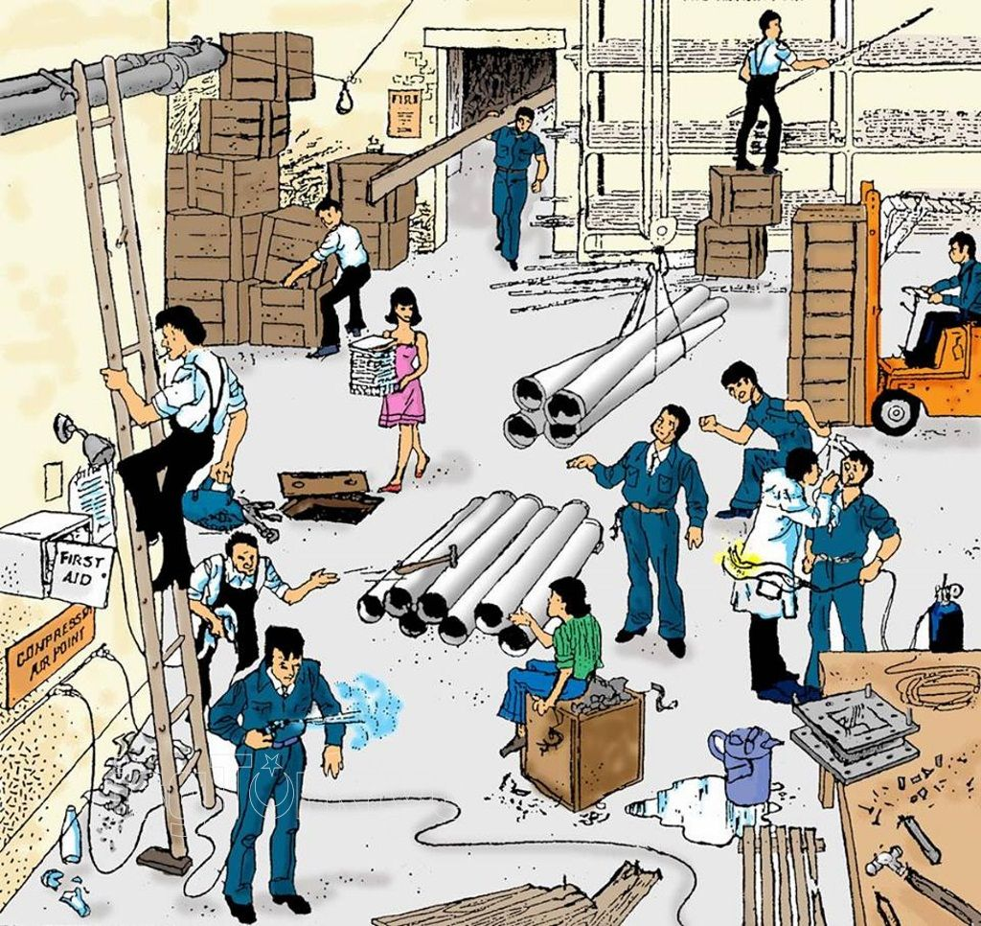

**FORM 9**

**PART I:**

**Comprehension topic questions: answer each question correctly. (5 points)**

1. ﻿﻿﻿What does a field service engineer do?

2. ﻿﻿﻿What improvement did Walton Electronics make to its workshops?

3. ﻿﻿﻿What experiment did Walton Electronics run?

4. ﻿﻿﻿How much did Walton Electronics save on electricity?

5. Talk about one of the greatest civil engineering achievements of the 20th century honored by ASCE.

**PART II: (10 points)**

**A. Vocabulary: Which part of speech is each word? Give a definition or use them in example sentence. (5 points)**

For example: **artificial**

Part of speech: adjective

Definition: not natural, made by people

Sentence: A modern artificial hip joint is designed to last for at least 15 years.

1. ﻿﻿﻿Supply – verb, make (something needed or wanted) available to someone ,The supermarket has a limited supply of fresh produce due to the recent bad weather

2. ﻿﻿﻿Device- noun , an object or machine that has been invented for a particular purpose, finding people trapped in collapsed buildings

3. ﻿﻿﻿Conical- adjective, shaped like a cone, my sister wears a conical birthday hat every year

4. ﻿﻿﻿Absenteeism – noun, a situation in which people are not at school or work when they should, the high rate of absenteeism is costing the company a lot of money

5. ﻿﻿﻿Safety- noun , a state in which are place where you are safe and not in danger or at risk for safety, we recommend you keep your seat belt loosely fastened during the flight

**B. Look at the picture and describe what you can see in the picture. Make more than ten sentences using modal verbs. (5 points)**

Use the language below:

- ﻿﻿How many people can you see on the picture?

- ﻿﻿What company does he work for?

- ﻿﻿Name the safety equipment.

- ﻿﻿Why must he wear the safety equipment?

- What clothes must he wear in the workplace?

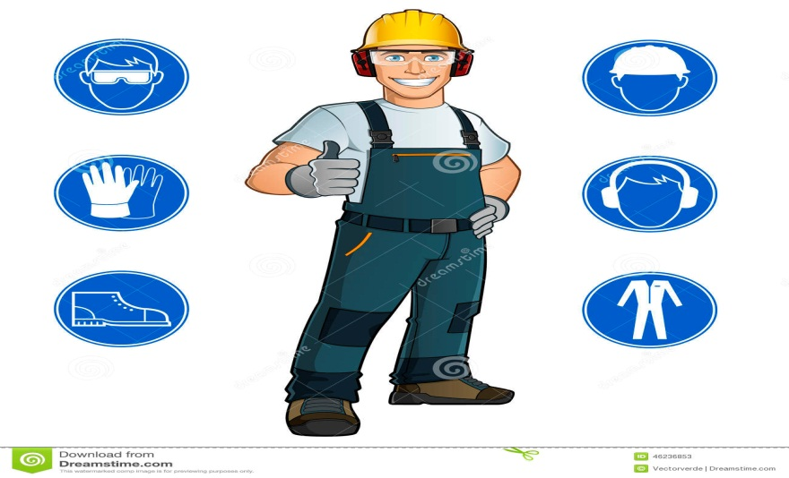

**FORM 10**

**PART I:**

**A. Comprehension topic questions: answer each question correctly. (5 points)**

1. ﻿﻿﻿How is tele-immersion different from tele-conferencing?

2. ﻿﻿﻿What's the best thing about tele-immersion?

3. ﻿﻿﻿Would you like to communicate with people via tele-immersion? Why or why not?

4. ﻿﻿﻿What are advantages and disadvantages one of following features: smart phone, robot, and laptop?

5. ﻿﻿﻿What does a software engineer do?

**PART II: (10 points)**

**A. Vocabulary: Which part of speech is each word? Give a definition or use them in example sentence. (5 points)**

For example: **artificial**

Part of speech: adjective

Definition: not natural, made by people

Sentence: A modern artificial hip joint is designed to last for at least 15 years.

1. ﻿﻿﻿Implant- noun and verb , medical device, An implant is a medical device or prosthesis that is surgically placed inside or on the body to treat a specific condition or improve bodily function.

2. ﻿﻿﻿Corrode-verb , destroy or damage gradually by chemical action , The metal fence was starting to corrode due to exposure to the salty ocean air

3. ﻿﻿﻿Spherical – adjective , refers to having the shape or form of a Sphere,The crystal chandelier hung in the center of the spherical ballroom, casting a dazzling display of light onto the polished marble floor.

4. ﻿﻿﻿Hammer - noun, Handheld tool with a heavy head on one end and a handle on the other end, I used a hammer to pound the nail into the board.

5. ﻿﻿﻿Improvement- verb , Refers to the process of making something better or enhancing its quality or effectiveness , With consistent effort and dedication, there is always room for improvement in any area of life

**B. Look at the picture and describe the earthquake safety procedures in the picture. Make more than ten sentences using modal verbs. (5 points)**

Use the languages below:

- What should you do? - What shouldn't you do?

1. You should drop, cover, and hold on during an earthquake to protect yourself from falling debris.

2. You shouldn't run or panic during an earthquake as it can lead to injuries.

3. You should calmly evacuate buildings and move to a safe area outside.

4. You shouldn't use elevators during an earthquake, as they may malfunction and trap you inside.

5. You should turn off gas and electricity to prevent fires and accidents.

6. You shouldn't use matches or lighters as gas leaks can cause explosions.

7. You should stay indoors during an earthquake and move away from windows.

8. You shouldn't go outside as falling debris can cause injuries.

9. You should take cover under a sturdy table or desk if inside during an earthquake.

10. You shouldn't stand in doorways as they are not necessarily the safest place during an earthquake.

11. You should secure heavy objects and furniture to prevent them from falling and causing damage.

